Sentiment Analysis Camera Application(Working Title)

The Application integrates emotion recognition, returning the confidence across a set of emotions for each face in the image

such as anger, contempt, disgust, fear, happiness, neutral, sadness, and surprise.

Young Hoon, Lee   
Dept. Earth Resources and Environmental Engineering  
Hanyang UniversitySeoul, Korea  
nobel6018@gmail.com

David, Jeon  
Dept. Computer Science  
Hanyang UniversitySeoul, Korea  
iuwios@naver.com

Ji Won, Hur  
Dept. Information System  
Hanyang UniversitySeoul, Korea  
hanante0203@gmail.comJi Yun, Park  
Dept. Business School  
Hanyang UniversitySeoul, Korea  
yuunnii315@gmail.com

*Abstract*— This application detects one human face in an image and gets back face rectangles for where in the image the face is, along with some attributes which contain machine learning-based predictions of facial features. Algorithm in application utilizes some of sentiment data and returns meaningful analysis results.

Keywords— face detection, machine learning, application diary, sentiment, appearance analysis, record

# Introduction

Sentiment Analysis Camera application provides users 4 basic functions: (1) analyze human emotion when uploading face photo, (2) record results on the account’s database with date, (3) input user’s personal comments with the photo, (4) AI chat service which offers words of sympathy depending on user’s mood.

# Service concept & Proposal

This application focuses on an image and analyze human’s emotion on it. The image, which is a photo of one’s face, sometimes could be more honest and raw data offered from human. Texts can be fabricated as much as he/she wants, on the other hands, face is hardly concealed. Most people write diary to record their mood of the day. However, we suggest NEW idea to record feelings in much simple and fabrication-free way. We aim for everyone’s facial expression at every moment.



In the application, main source is machine learning technology. We highly use Microsoft Azure Face API to detect facial features. 27 types of data are extracted from one-time detection. They are processed and expanded to new service.

# Development Environment

*A. Software development platform*

a) Android/IOS Platform

Ideally, the team will aim to develop an application compatible for both Android and IOS. This is to ensure the best daily usability as most people spend majority of their time with smartphones. The concept of taking a picture and recording any time the user wants is most efficient in a small device which would be a phone. This allows any user to take a picture any place or time he or she is carrying a phone which is also in the same direction that this application aims.

b) Programming Language

* Java

Java is a language that is needed to code in an IDE called Android Studio. The main execution codes are written in java such as calling a widget for use from an xml or connecting to different servers.

* Python 3.7

To use Django version 2 or higher, the recommended python version is 3.

* JavaScript

React Native needs JavaScript library for building user interfaces.

* XML

XML is needed to design the user interface in Android Studio applications. Font, text, widgets, application format is all designed in the XML.

c) Cost Estimation

The team has estimated the monthly cost for a target user of 1,000 and an average of 3 images taken per user daily. The total cost is 164.2USD per month. There is no extra cost for software or hardware.

* Microsoft Azure Cost

The team is using a 12 month-free version of Microsoft Azure with 20 transactions per minute and 30,000 free transactions per month. However, for long term maintenance the Standard version is required which taking into consideration that one person takes about 3 images a day and 1,000 users as a target. The price for 1,000 transaction is 0.8$ which would make monthly cost (3images*1000users*30days)*(0.8USD/1000transactions) = 72USD.

* Firebase Cost

The Spark version of Firebase API provides 1GB of free real-time data storage. However, for 1,000 users to save text data about 3 times a day and each save to be 250 characters, the needed data size would be 1000users * 250characters *3times = 22,500,000 characters and adding a few more characters for additional text the approximate data size is 32MB. For 25USD, 2.5GB is provided. After the 1GB is used, 3.2USD is needed monthly.

* Cloudinary Cost

Cloudinary offers one of the best prices for saving media data. For 1,000 users taking an average of 3 images a day takes 3images * 1000 users* 30days = 90,000 images in one month. Depending on the image quality, the data size may differ but the average for 90,000 images is set to 60 gigabytes which costs 89USD monthly.

d) Framework

* Django 2.1.2
* Django Rest Framework 3.10.2
* React Native 0.59.8
* React ^16.8.3
* Expo ^35.0.0
* Android Studio 5.1

e) API

* Microsoft Azure Face 1.24.0
* Firebase 17.0.0
* Cloudinary 1.20.0

f) Library

* Sendbird

g) Repository

* Github

*B. Software in use*

a) Daylio

It helps users to establish more productive lifestyles and to better understanding their own habits by keeping track of their moods while writing a diary. Its major features are as follows:

1. The most prominent feature of this is that if users record several emotions in a day, their average emotion sets as a representative value.
2. Although it sets 'Very good', 'Good', 'Normal', 'Bad' and 'Very bad' to default values, users can change or add emotions they want.
3. In [Statistics] tab, users can check 'Change of moods over the month', 'Consecutively recorded days', 'The number of moods per day' and 'Statistics of moods by day'.
4. It sets 'Very good' to 'Very bad' from 5 to 1 and by colors, it is easy to see the emotion changes by date on the line graph.
5. In [Calendar] tab, if the user has recorded n emotions, each emotion may be displayed by one-nth at that date on the calendar and can also be viewed as an average of the emotions.



Daylio

b) Mind i/o (마인드 i/o)

It is an integrated platform for managing the health of the mind. Its major features are as follows:

1. It has a data-based machine learning chatbot that learns the words users use, which is called 'io chatbot' learning minds.
2. It provides various meditation methods and healing music from the basic course.
3. It allows users to record their feelings in writing with photos using 'a mind diary'. If the diary is public, it can be used as SNS. When the diary is private, it can be used as a personal diary.
4. It allows users to communicate with other users who have similar interests or pains.



Mind i/o

c) Emotional Diary (감정일기)

It is an application that tells you how you felt at that time by recording users' emotions at the end of each day. Its major features are as follows:

1. It allows users to write 'an emotional diary'. This includes an emotion, the intensity of the emotion and contents. Users can add locations and photos to their diary. Based on the number of diaries stored in a database, it outputs a user-only emotional charts.
2. It has 'emotional folders' where users can check their diaries stored in a database by emotions. Regardless of emotions, users can view the entire diaries they wrote previously.
3. It provides a recording service where users can record their own feelings by talking to their cellphones.
4. It marks users' current locations and ones where users were writing a diary at that moment. This service is based on Google-Map.



Emotional Diary

d) Bora - Look at your feelings (당신의 감정을 보라)

It is the simplest one among emotional analyzing applications. It only shows the monthly representative emotion by colors on the calendar. The major feature is that user can set the desired color out of eight emotions: joy, happiness, excitement, peace, sadness, anxiety, anger, and (custom value). After this setting being completed, the colors that a user set are displayed in a palette format.



Bora

C. *Development task distribution*

Idea was from Software Engineering Project group in Hanyang University. The group is composed of Y.H. Lee, David Jeon, J.W. Hur, and J.Y. Park. Every team member participates in planning, designing, and developing. Also, we manage overall development process in Github public repository. Details in *XI. ROLE ALLOCATION*.

# Specifications

**1. Login**

1.1 The purpose of the Login page

This is the screen that pops up the first time when a user runs this application. An introduction to the app appears on the screen, allowing the user to briefly know what the app is about. Also, to sign up, a user can subscribe by linking his or her Google account or creating a new account within the application. This allows users to store recorded emotions and photos in their own database, so that data can be preserved if the mobile phone is changed or reinstalled after deleting the application. 'Firebase' will be used as a database system.

1.2 Function details

1.2.1 Link to user’s Google account

*ID:* 4101

*Type:* Requirement

This application integrates Google Login with itself to make Firebase certify users by Google account. When linked to a Google Account, the user can create a nickname, password, and password checkboxes for use in the application and select the sex corresponding to him or her.

*Process*

* Click the 'Login with Google Account' button.
* Select the account that he or she wants to use in the application when having multiple Google accounts.
* Complete the nickname, password, and password checkboxes for the application to use and selects the appropriate sex.

1.2.2 Creating a new account

*ID:* 4102

*Type:* Requirement

This application can authenticate users with an email address and password. Unlike 1)'s *'Link to user’s Google account'*, users need to set up separate e-mails to be used in the application before being authenticated, and then create an account after filling in the nickname, password and password check box, just like *‘Link to user’s Google account’.*

*Process*

* Click the *'Creating a new account'* button.
* Complete the email, password, and password check boxes for the application to use.
* Type in the nickname, date of birth, and select the sex.
* Click the OK or Cancel button to complete the membership.

**2. Main(home)**

2.1 The purpose of the Main page

This section is the center of the application which is the first screen to be seen after a user creates an account or log in to the application. When a user speaks to an AI chatbot by clicking 'Talking', this application prints out words that suit a user's mood and shows various emotional variation graphs daily, weekly, or monthly. Since this application is to record each user's daily, weekly, and monthly emotional changes, it is important to show a user-centered screen rather than a community-centered one on the first screen page.

2.2 Function details

2.2.1 AI chatbot

*ID:* 4201

*Type:* Requirement

This AI chatbot is a service that allows users to share emotional interactions by showing messages that suit the user's chosen mood. Therefore, it sympathizes with and encourages the user's feelings.

*Process*

* A user clicks on the Select box at the top of the speech bubble.
* A list of eight emotions pops up on the screen.
* A user chooses the feelings that he feels on that day.
* A sentence or a word suitable for the emotion appears in the speech balloon. At this time, the writing can be one of the contents of a diary previously written by the user, or it can use a famous phrase brought from Naver famous phrase book API.
* When the Refresh button at the bottom of the speech balloon is being pressed, different words will appear on the screen each time.

2.2.2 Mind Control Graph

This section shows a total of three graphs by obtaining statistics based on the user's photographic and written feelings. The first graph is radial which shows how often a user feels the emotions over a week or a month. The second is an emotional trend graph that identifies the number of emotions or the intensity change of emotions depending on how they are developed. The third is the total emotional trend line, which allows a user to see the eight emotions changing at once.

2.2.2.1 Radial graph

*ID:* 4202

*Type:* Requirement

Eight emotions are grouped into five sections, allowing users to see how often the group of emotions appeared during the week or month. The eight emotions are 'anger', 'contempt', 'disgust', 'fear', 'happiness', 'normal', 'sadness' and 'surprise'. In this application, 'anger' is classified as the first group, 'contempt' and 'disgust' as the second group, 'fear' as the third group, 'sadness' as the fourth group, 'happiness' as the fifth group, and 'surprise' as the sixth group.

*Process*

* On the first screen, users can check the frequency of their emotions over a week in a radial graph format.
* If the user clicks the right arrow at the top of the graph, it shows the feelings that a user has felt over a month.



Radial graph type

2.2.2.2 Trend line graph by emotion

*ID:* 4203

*Type:* Requirement

Of the total eight emotions in the Select box, a graph is displayed that corresponds only to the feeling selected by the user. The frequency of each emotion is stored in the application's database user by user, and the stored value is shown in the graph. When developed by date, the x-axis of the graph displays the date and day, and the y-axis displays the intensity of the emotion from 0 to 100%. The default value of the intensity of the emotion is zero, and it is displayed on the graph if no emotion has been felt on a day.

When developed by week, the x-axis of the graph displays the corresponding month and week, and the y-axis is the frequency of the emotion, with a value of 0 to 7.

*Process*

* A user selects one emotion from the Select box.
* A trend line graph of the selected emotion is displayed at the bottom of the Select box.



Trendline graph type

2.2.2.3 Total emotional trend line graph

*ID:* 4204

*Type:* Requirement

All eight emotions are displayed on the graph at once, so a user can see the changes in all emotions. Like the trend line graph of (2), the values of the x- and y-axes vary depending on whether to develop by the date or by the week. In the former case, the x-axis displays the date and day of the week, and the y-axis displays the intensity of the emotion. However, in the latter case, the x-axis displays the corresponding month and the week, and the y-axis displays the frequency of the emotions. Each emotional graph line is differentiated by colors.

*Process*

* All eight emotions are displayed on the graph at once.
* Users can swipe graphs left and right with their fingers.
* If a user clicks on the emotions shown on the left side of the y-axis, the matching emotion graph line will appear highlighted.

**3. Camera**

3.1 The purpose of the Camera page

This section is to provide camera activation and data analysis support. The following steps are rough user experience. Taking a photo, saving photo, and user can get final analysis results in the user interface. In the backend system, face detection, face attribute recognition, parsing data are happened.

Moreover, user can input text which is about the photo or daily feeling. Each data is independently saved and managed in the user account’s database. User can read any records (photo and user-creating text) of exact date anytime.

3.2 Function details

3.2.1 Photo taking and saving

*ID:* 4301

*Type:* Requirement

The application shall activate mobile built-in camera application when accessed by user. Both front-side camera and back-side camera are possible. Photo size is 3:4 or 9:16 or 1:1. Any case to take a photo is possible when it returns a photo of user face. Also, user can import another photo from mobile album. Video can’t be used.

* taking a photo service
* saving a photo in a designated album service
* importing a photo from album service
* an album linking service

3.2.2 Image detection

*ID:* 4302

*Type:* Requirement

The application returns face expression analysis results when a photo is entered which is an image data. Before analyzing, the system detects one of more human faces in the image and gets back face rectangles for where in the image the face is. The red-colored rectangle represents that it has success in finding one human face.

* an image loading service
* a face detection service

3.2.3 Image analysis

*ID:* 43021

*Type:* Requirement

The application detects and recognizes several attributes in an image. The face attribute features available are: age, emotion, gender, pose, smile, and facial hair. It doesn’t show all to user. The data processing occurs in parsing and partial extraction. And here are more details about meaningful data list.

* hair: bald / color (brown, black, red, blond, gray, other)
* face hair: moustache, beard, sideburns
* smile
* head pose: pitch, roll, yaw
* gender
* age
* make-up: eye make-up, lip make-up
* emotion: anger, contempt, disgust, fear, happiness, neutral, sadness, surprise
* occlusion: forehead, eye, mouth
* accessories: glasses



3.2.4 Sentiment prediction

*ID:* 4303

*Type:* Requirement

After detection, the application returns face expression analysis results. It is along with some attributes of facial features as previously stated. They are machine learning-based predictions. The algorithm extracts 27 types of data for each face in the image. And it makes a meaningful analysis results based on application system needs.

* a sentiment prediction service
* a 27 types of facial features extraction service
* a data grouping service: emotions, appearance, etc.



3.2.5 Comment suggestion

*ID:* 4304

*Type:* Requirement

The application automatically suggests some comments according to user’s mood. They are represented with analysis results at the same time. For example, when the application detects user’s face and concludes ‘happiness’, the comment like ‘why don’t you go to park and have a coffee to fully enjoy your happiness?!’ appears. Database has several text data and they are set by developer in advance.

* a touching comment providing service

3.2.6 Data record

*ID: 4305*

*Type:* Requirement

The application provides not only emotion analysis service but also other additional services utilizing the photo. Most of all, the application aims for user’s free expression at every moment. In this reason, the application supports data record service as well. Data includes photo, sentiment analysis result, and text(comment).

* a user comment record service
* an account-utilization service: every data store in user’s own database
* a data saving service: photo, text, date, sentiment analysis result

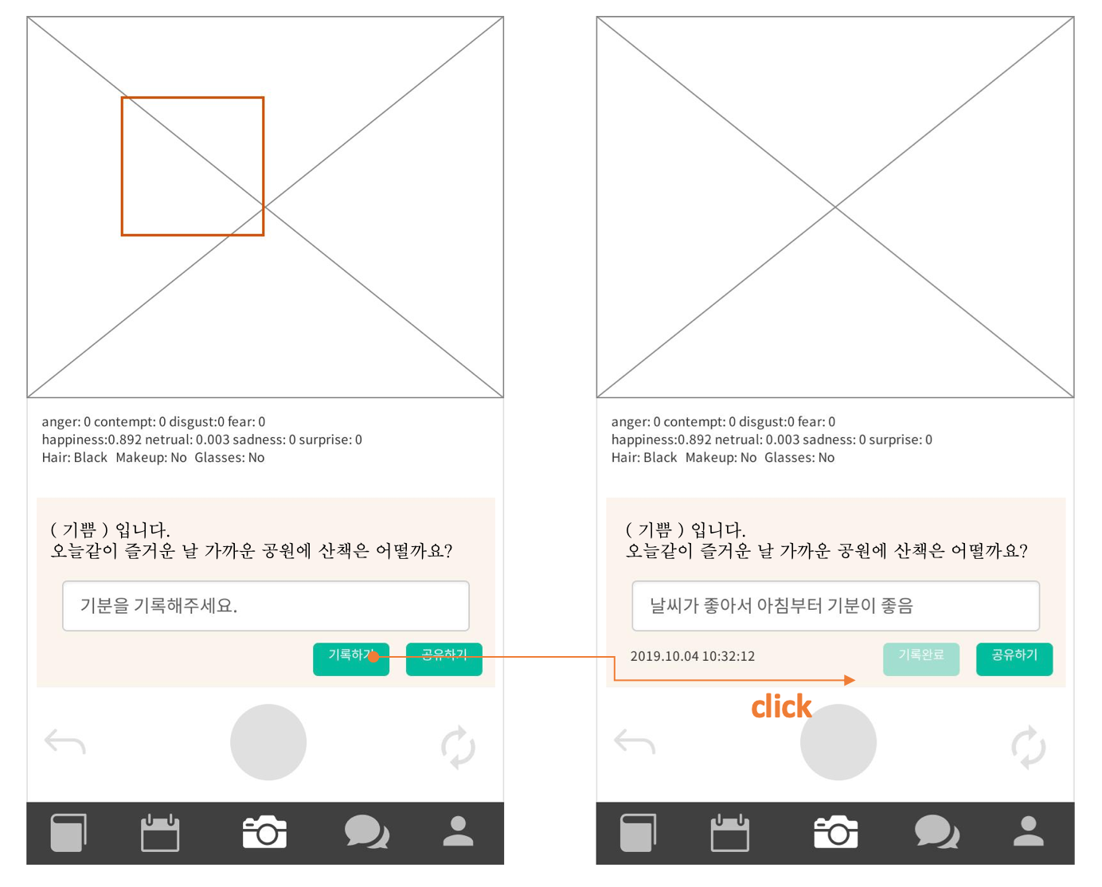

pre-wireframe

**4. Archive**

4.1 The purpose of the Archive page

This section is to provide user’s history. Users can review her or his emotion analyzed by AI backend system. The history contains not only the picture but also emotion analysis, her/his comments.

Users can see their history after taking a photo. User can see the history since every photo, emotion analysis and comment are saved in database. Cloudinary saves photos. Google Firebase save comments and analyzed emotions.

4.2 Function details

4.2.1 API call with authentication

*ID:* 4401

*Type:* Requirement

The archive needs user authentication. Photo and emotion is important private information. The application is authenticated by google firebase authentication API. The application takes user’s unique id through firebase authentication process. Whenever user call APIs for example, retrieve photos, comments and emotion list in this section, authentication is required.

*Process*

* User should call API with header which has “Authorization”.
* Backend service requires the header’s authorization parameter.
* If authoritative value is correct and valid, backend responses with status 200 with contents
* If authorization value is expired or invalid, backend responses with status 403 error (Authorization Forbidden)

4.2.2 Call Cloudinary API

*ID:* 4402

*Type:* Requirement

User photos is necessary component to archive. Photos are saved in cloudinary. Cloudinary provides many APIs, from CRUD (create, retrieve, update, delete) to resizing, rotating and so on(for more, refer 4.2.3). In this section, retrieve images API is used. The application calls retrieve API with the header which has authorization key-value pair.

*Process*

* The application makes retrieve image API call. Authorization is essential.
* Backend service check authorization value and then bring user images back if authorization is verified.
* The application takes and displays the images.

4.2.3 Call Firebase API

*ID:* 4403

*Type:* Requirement

Emotion and comments are stored in firebase database. Firebase database is real-time NoSQL database. It is available even when offline. The process is similar to 4.2.2 cloudinary API call. The application makes Firebase database retrieve call. It is surely necessary ‘authorization’. Firebase database service check authorization verification. If authorization is passed, retrieve the target user’s personal data – emotion and comments. These are displayed together with user photos (taken from 4.2.2)

*Process*

* The application calls retrieve database API.
* Firebase check authorization value and then response user’s data – emotions and comments.
* The application takes and displays the emotion and comments with user photos.

4.2.3 Display archive history list

*ID:* 4404

*Type:* Requirement

Each history of archive consists of picture, representative emotion and shortened comments. The application asks all the images from cloudinary API, all emotions and comments from Firebase database API. And then reformat those things and make archive history list.

4.2.3 Display history detail view

*ID:* 4405

*Type:* Requirement

Each history detail has user photo, emotion and comments. Detail archive history can present more information. Detail emotion statistics and full comments.

The application requests a specific photo from cloudinary API and equivalent emotion and comment from firebase database.

# Service details

*A. Service Flow Map*

*…*

*B. Wireframe*

*…*

*C. Functional Specification*

*…(table)*

# Design

*A. Architecture design*

*…*

*B. User Interface*

*…(ui image)*

# Application Implementation

*A. Source code*

*…*

*B. Testing*

*…*

*C. Use cases*

*…*

# Expectancy Effects

## Application Distribution

* Amazon RDS for MySQL

## Customer Values

1. Qualitative Values

…

1. Quantitative Values

…

*C. Market Research*

…

# Role Allocation

|  |  |  |  |
| --- | --- | --- | --- |
| 1 | **Roles** | **Name** | **Task description** |
| User | J.W. | QA, market searching |
| Customer | - | - |
| SW developer 1 | David | programming |
| SW developer 2 | Y.H. | programming |
| Development manager | J.Y. | planning, designing |
| 2 | **Roles** | **Name** | **Task description** |
| User | David  J.W.  J.Y.  Y.H. | user-side experience |
| Customer | - | - |
| SW developer | David | programming |
| Development manager | J.W.  J.Y.  Y.H. | planning, designing |
| 3 | **Roles** | **Name** | **Task description** |
| User |  |  |
| Customer |  |  |
| SW developer |  |  |
| Development manager |  |  |
| 4 | **Roles** | **Name** | **Task description** |
| User |  |  |
| Customer |  |  |
| SW developer |  |  |
| Development manager |  |  |

*\*Every role is variable according to situation*